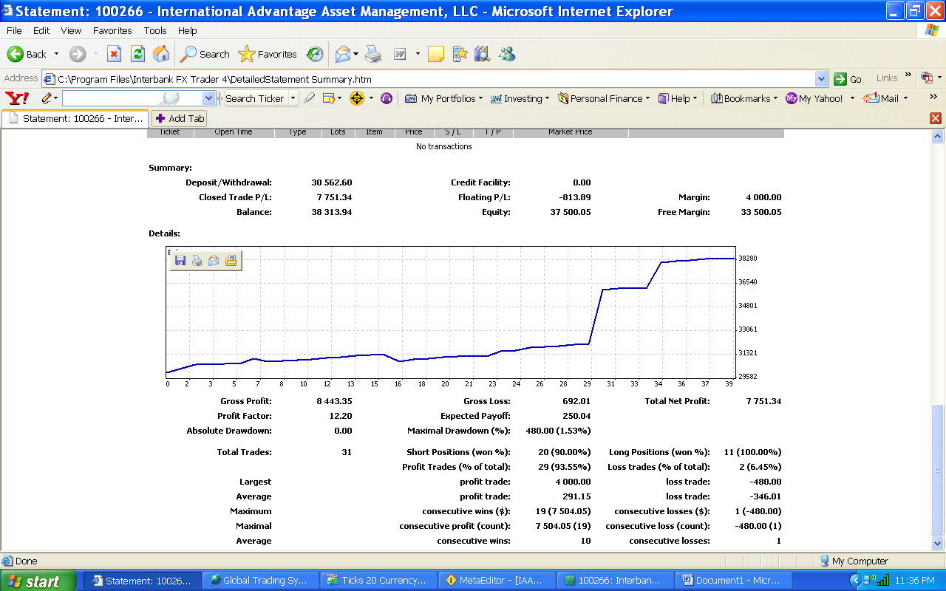

For integrity’s sake, 4 of the 31 trades were not FireBird trades and $5,900.00 in gross profit is not attributable to FireBird. FireBird had no losing trades. These results are taken from the week beginning November 7th .

MoneyMa$ter

